Question : Program to add, remove, clear contents from list box.

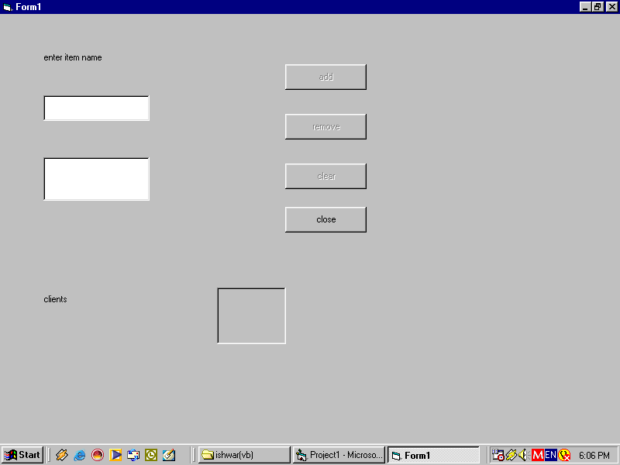

Private Sub Command1_Click()
List1.AddItem Text1.Text
Text1.Text = ""
Text1.SetFocus
Label3.Caption = List1.ListCount
Command2.Enabled = List1.ListCount > 0
Command3.Enabled = List1.ListCount > 0
End Sub

Private Sub Command2_Click()
Dim ind As Integer
ind = List1.ListIndex
If ind >= 0 Then
List1.RemoveItem ind
Label3.Caption = List1.ListCount
End If
Command2.Enabled = List1.ListCount > 0
Command3.Enabled = List1.ListCount > 0
End Sub

Private Sub Command3_Click()
List1.Clear
Command2.Enabled = False
Command3.Enabled = False
Label3.Caption = List1.ListCount
End Sub

Private Sub Command4_Click()
End
End Sub

Private Sub Form_Load()
Command2.Enabled = List1.ListCount > 0
Command3.Enabled = List1.ListCount > 0
List1.Text = ""
End Sub

Private Sub Text1_change()
Command1.Enabled = (Len(Text1.Text) > 0)
End Sub

Private Sub Text1_GotFocus()
Command1.Enabled = Len(Text1.Text) > 0
End Sub

Question : Program to add, remove, clear contents from combo box.

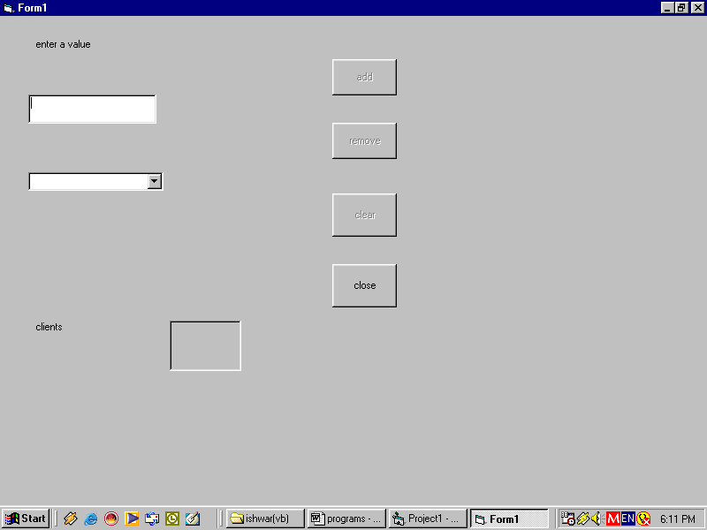

Private Sub Command1_Click()
Combo1.AddItem Text1.Text
Text1.Text = ""
Text1.SetFocus
Label3.Caption = Combo1.ListCount
Command2.Enabled = Combo1.ListCount > 0
Command3.Enabled = Combo1.ListCount > 0
End Sub

Private Sub Command2_Click()
Dim ind As Integer
ind = Combo1.ListIndex
If ind >= 0 Then
Combo1.RemoveItem ind
Label3.Caption = Combo1.ListCount
End If
Command2.Enabled = Combo1.ListCount > 0
Command3.Enabled = Combo1.ListCount > 0
End Sub

Private Sub Command3_Click()
Combo1.Clear
Command2.Enabled = False
Command3.Enabled = False
Label3.Caption = Combo1.ListCount
End Sub

Private Sub Command4_Click()
End
End Sub

Private Sub Form_Load()
Command2.Enabled = Combo1.ListCount > 0
Command3.Enabled = Combo1.ListCount > 0
Combo1.Text = ""
End Sub

Private Sub Text1_change()
Command1.Enabled = (Len(Text1.Text) > 0)
End Sub

Private Sub Text1_GotFocus()
Command1.Enabled = Len(Text1.Text) > 0
End Sub

Question : Program to count the number of digits in a number.

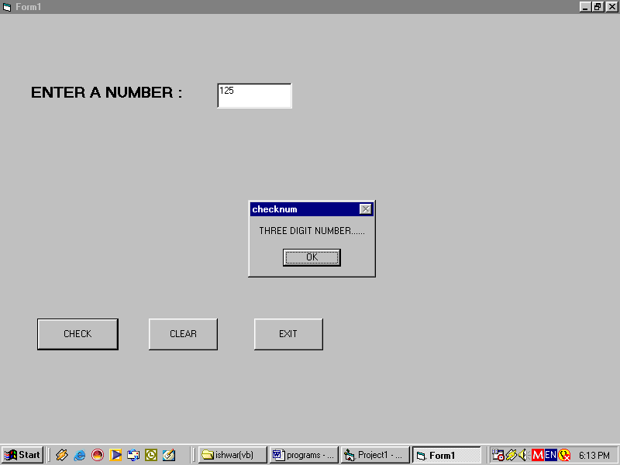

Private Sub Command1_Click()
A = Val(Text1.Text)
If (A >= 0 And A < 10) Then
MsgBox "SINGLE DIGIT NUMBER......"
ElseIf A >= 10 And A < 100 Then
MsgBox "TWO DIGIT NUMBER......"
ElseIf A >= 100 And A < 1000 Then
MsgBox "THREE DIGIT NUMBER......"
Else
MsgBox "NOT IN THE LIST......"
End If
End Sub

Private Sub Command2_Click()
Text1.Text = ""
End Sub

Private Sub Command3_Click()
End
End Sub
Question : Program to add, remove, clear contents from list box.



Private Sub bl_Click()
colorform.BackColor = QBColor(1)
bl.Enabled = False
gr.Enabled = True
rd.Enabled = True
End Sub

Private Sub ex_Click()
End
End Sub

Private Sub Form_Load()
gr.Enabled = False
colorform.BackColor = QBColor(2)
colorform.WindowState = 0
sml.Enabled = False
End Sub

Private Sub gr_Click()
colorform.BackColor = QBColor(2)
bl.Enabled = True
gr.Enabled = False
rd.Enabled = True
End Sub

Private Sub lrg_Click()
colorform.WindowState = 2
lrg.Enabled = False
sml.Enabled = True
End Sub

Private Sub rd_Click()
colorform.BackColor = QBColor(4)
bl.Enabled = True
gr.Enabled = True
rd.Enabled = False
End Sub

Private Sub sml_Click()
colorform.WindowState = 0
lrg.Enabled = True
sml.Enabled = False
End Sub

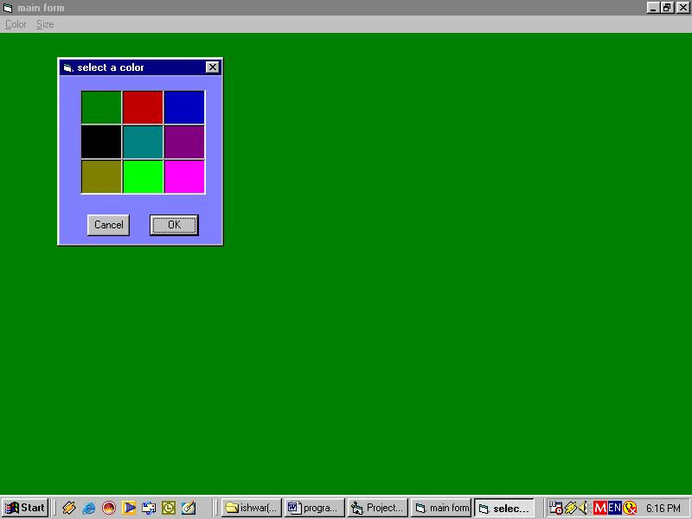

Private Sub ex_Click()
End
End Sub

Private Sub fc_Click()
Load Form1
Form1.Show
End Sub

Private Sub Form_Load()
colorform.BackColor = QBColor(7)

colorform.WindowState = 0
sml.Enabled = False
End Sub

Private Sub lrg_Click()
colorform.WindowState = 2
lrg.Enabled = False
sml.Enabled = True
End Sub

Private Sub sml_Click()
colorform.WindowState = 0
lrg.Enabled = True
sml.Enabled = False
End Sub

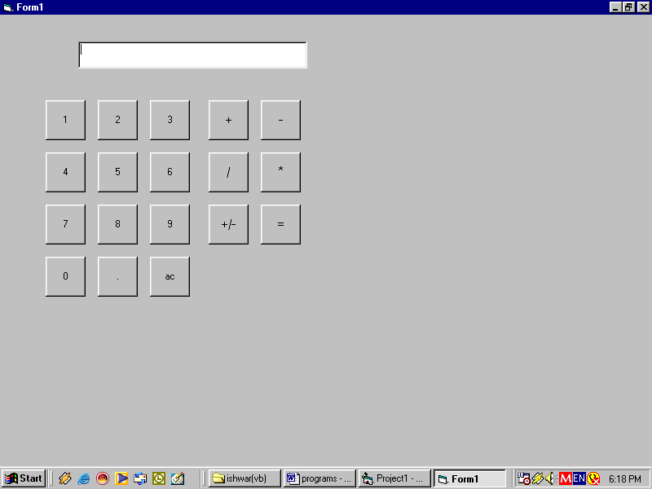

Dim curval As Double
Dim preval As Double
Dim choice As String
Dim result As String

Private Sub cmd_Click(Index As Integer)
Text1.Text = Text1.Text & cmd(Index).Caption
curval = Val(Text1.Text)
End Sub

Private Sub cmdac_Click()
curval = preval = 0
Text1.Text = ""
End Sub

Private Sub cmdequal_Click()
Select Case choice
Case "+"
result = preval + curval
Text1.Text = Str(result)
Case "-"
result = preval - curval
Text1.Text = Str(result)
Case "*"
result = preval * curval
Text1.Text = Str(result)
Case "/"
result = preval / curval
Text1.Text = Str(result)
End Select
curval = result
End Sub

Private Sub cmdminus_Click()
Text1.Text = ""
preval = curval
curval = 0
choice = "-"
End Sub

Private Sub cmdmul_Click()
Text1.Text = ""
preval = curval
curval = 0
choice = "*"
End Sub

Private Sub cmdplus_Click()
Text1.Text = ""
preval = curval
curval = 0
choice = "+"
End Sub

Private Sub mddiv_Click()
Text1.Text = ""
preval = curval
curval = 0
choice = "/"
End Sub

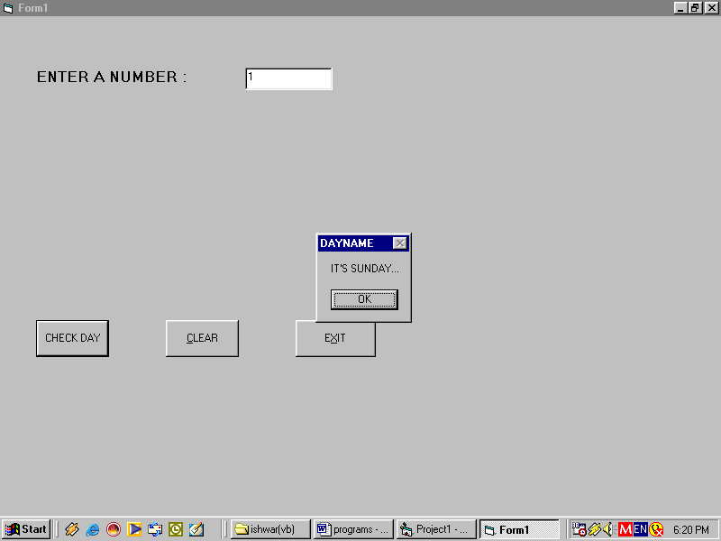

Private Sub Command1_Click()
Dim N As Integer
N = Val(Text1.Text)
Select Case N
Case 1: MsgBox " IT'S SUNDAY..."
Case 2: MsgBox "IT'S MONDAY..."
Case 3: MsgBox "IT'S TUESDAY..."
Case 4: MsgBox " IT'S WEDNESDAY..."
Case 5: MsgBox "IT'S THURSDAY..."
Case 6: MsgBox "IT'S FRIDAY..."
Case 7: MsgBox " IT'S SATURDAY..."
Case Else: MsgBox "INVALID DAY..."
End Select
End Sub

Private Sub Command2_Click()
Text1 = ""
End Sub

Private Sub Command3_Click()
End
End Sub

Question : Program to show the use of drive, directory and file list box.

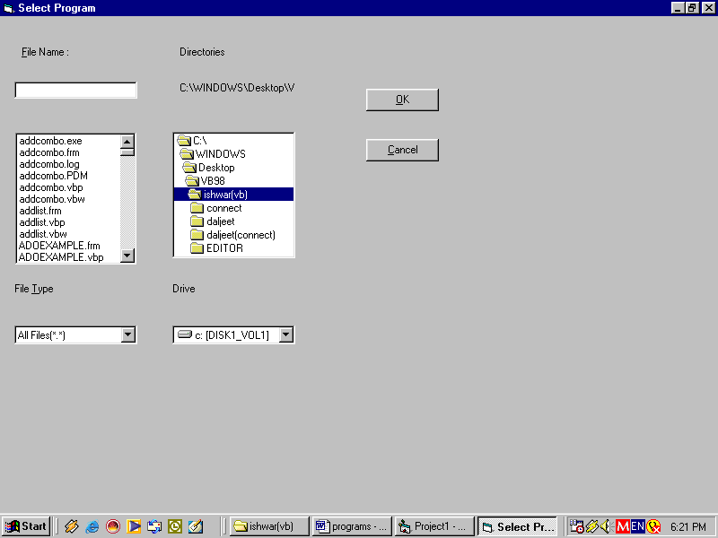

Option Explicit

Private Sub cmdcancel_Click()
End
End Sub

Private Sub cmdOK_Click()
If Text1.Text = "" Then
MsgBox "No file was selected....."
Else
MsgBox "Selected file is " + Text1.Text
End If
End Sub

Private Sub Combo1_Click()
Select Case Combo1.ListIndex
Case 0:
File1.Pattern = "*.*"
Case 1:
File1.Pattern = "*.doc"
Case 2:
File1.Pattern = "*.txt"
End Select
End Sub

Private Sub Dir1_Change()
File1.Path = Dir1.Path
Label4.Caption = Dir1.Path
End Sub

Private Sub Drive1_Change()
On Error GoTo ErrorTrap
Dir1.Path = Drive1.Drive
Exit Sub
ErrorTrap:
MsgBox "Drive Error !", vbExclamation, "Error....."
Drive1.Drive = Dir1.Path
Exit Sub
End Sub

Private Sub File1_Click()
Text1.Text = File1.FileName
End Sub

Private Sub Form_Load()
Combo1.AddItem "All Files(*.*)"
Combo1.AddItem "Doc Files(*.DOC)"
Combo1.AddItem "Text Files(*.TXT)"
Combo1.ListIndex = 0
Label4.Caption = Dir1.Path
End Sub

Question : Program to enter the marks and print the grade.

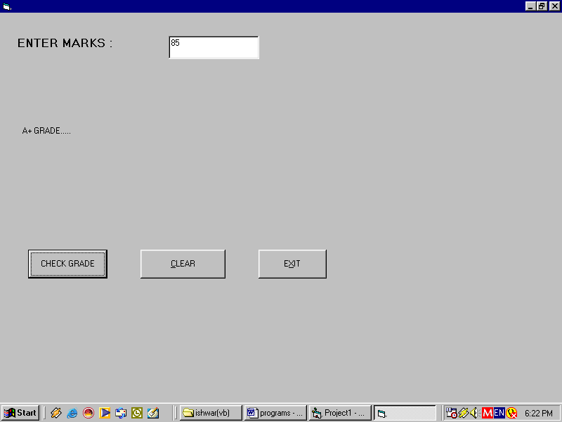

Private Sub Command1_Click()
Dim M As Integer
M = Val(Text1)
If (M >= 0 And M < 50) Then
Label2.Caption = "FAILED....."
ElseIf (M >= 50 And M < 60) Then
Label2.Caption = "C GRADE....."
ElseIf (M >= 60 And M < 70) Then
Label2.Caption = "B GRADE....."
ElseIf (M >= 70 And M < 80) Then
Label2.Caption = "A GRADE....."
ElseIf (M >= 80 And M <= 100) Then
Label2.Caption = "A+ GRADE....."
Else
Label2.Caption = "INVALID MARKS....."
End If

End Sub

Private Sub Command2_Click()
Text1 = ""
Label2.Caption = ""
End Sub

Private Sub Command3_Click()
End
End Sub

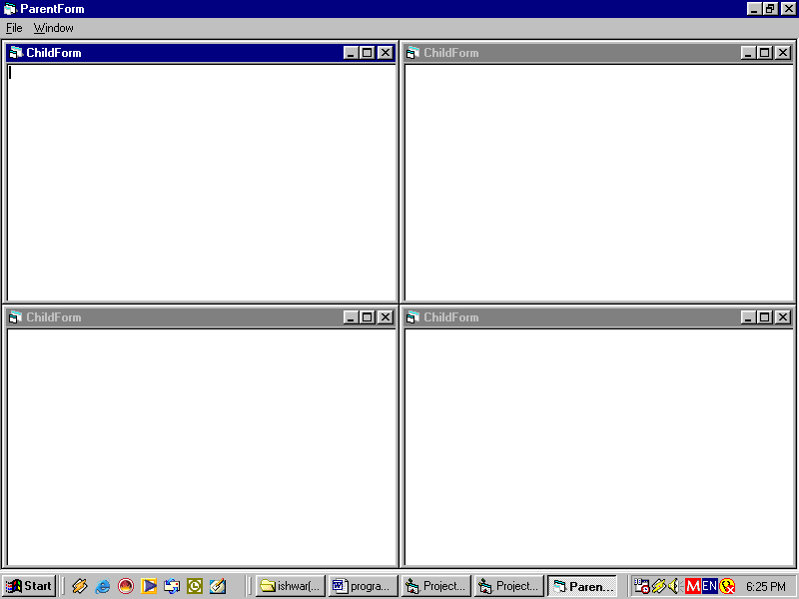

Private Sub mncascade_Click()
mdiform1.Arrange vbCascade
End Sub
Private Sub mnexit_Click()
End
End Sub
Private Sub mnnew_Click()
Dim newform As New Form1
newform.Show
End Sub

Private Sub mntile_Click()
mdiform1.Arrange vbTileHorizontal
End Sub

Question : Program to change the background colours of text box using scroll bars.

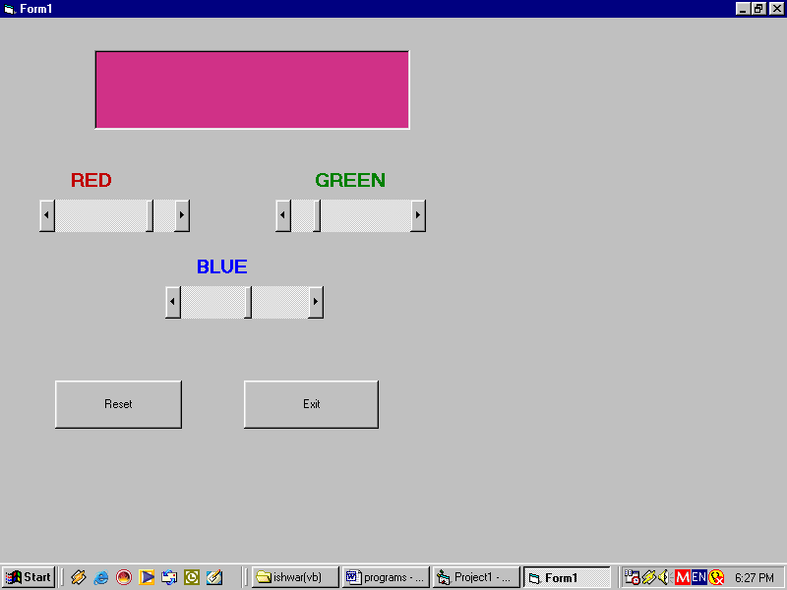

Dim a, b, c As Integer

Private Sub Command1_Click()
a = 0
b = 0
c = 0
Text1.BackColor = RGB(a, b, c)
HScroll1.Value = 0
HScroll2.Value = 0
HScroll3.Value = 0
End Sub

Private Sub Command2_Click()
End
End Sub

Private Sub HScroll1_Change()
a = HScroll1.Value
Text1.BackColor = RGB(a, b, c)
End Sub

Private Sub HScroll2_Change()
b = HScroll2.Value
Text1.BackColor = RGB(a, b, c)
End Sub

Private Sub HScroll3_Change()
c = HScroll3.Value
Text1.BackColor = RGB(a, b, c)
End Sub

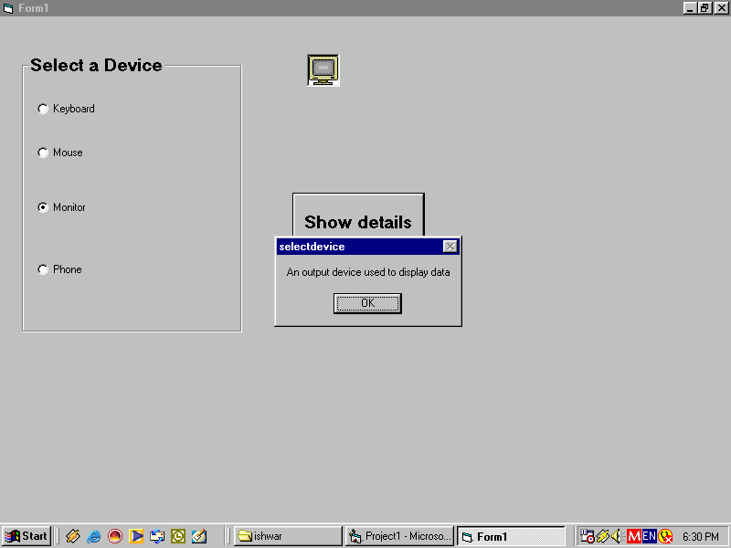

Private Sub Command1_Click()
Select Case True
Case Option1.Value:
MsgBox ("An input device used to type and enter data")
Case Option2.Value:
MsgBox ("An input device used for clicking various things")
Case Option3.Value
MsgBox ("An output device used to display data")
Case Option4.Value
MsgBox ("A device used for communication purpose")
End Select
End Sub

Private Sub Option1_Click()
Picture1.Picture = LoadPicture("d:\vb98\ishwar\keyboard.ico")

End Sub

Private Sub Option2_Click()
Picture1.Picture = LoadPicture("d:\vb98\ishwar\mouse.ico")
End Sub

Private Sub Option3_Click()
Picture1 = LoadPicture("d:\vb98\ishwar\monitor.ico")
End Sub

Private Sub Option4_Click()
Picture1 = LoadPicture("d:\vb98\ishwar\phone.ico")
End Sub

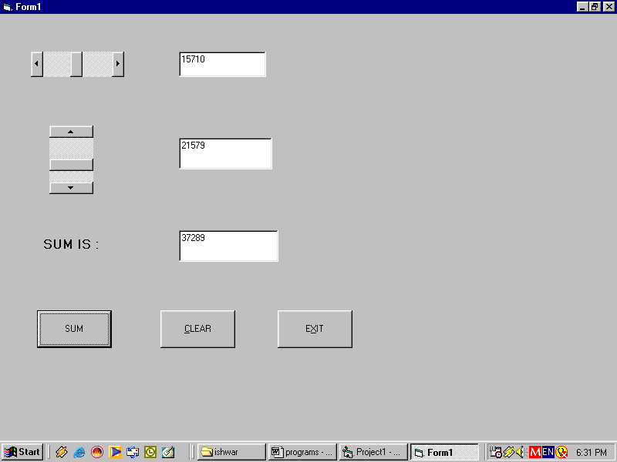

Private Sub Command1_Click()
Text3 = Val(Text1) + Val(Text2)
End Sub

Private Sub Command2_Click()
Text1 = ""
Text2 = ""
Text3 = ""
End Sub

Private Sub Command3_Click()
End
End Sub

Private Sub HScroll1_Change()
Text1 = HScroll1.Value
End Sub
Private Sub VScroll1_Change()
Text2 = VScroll1.Value
End Sub

Question : Program to show the use of timer control.

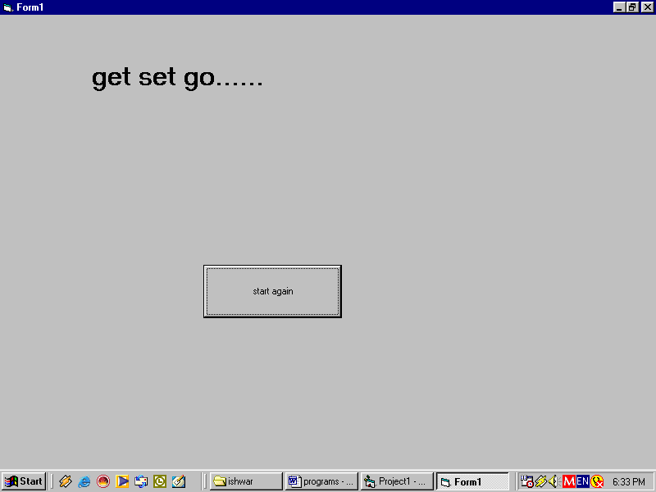

Dim i As Integer

Private Sub Command1_Click()
i = 0
End Sub

Private Sub Timer1_Timer()
i = i + 1
Label1.Caption = i

End Sub

Question : Program to transfer the contents of one list box into another list box.

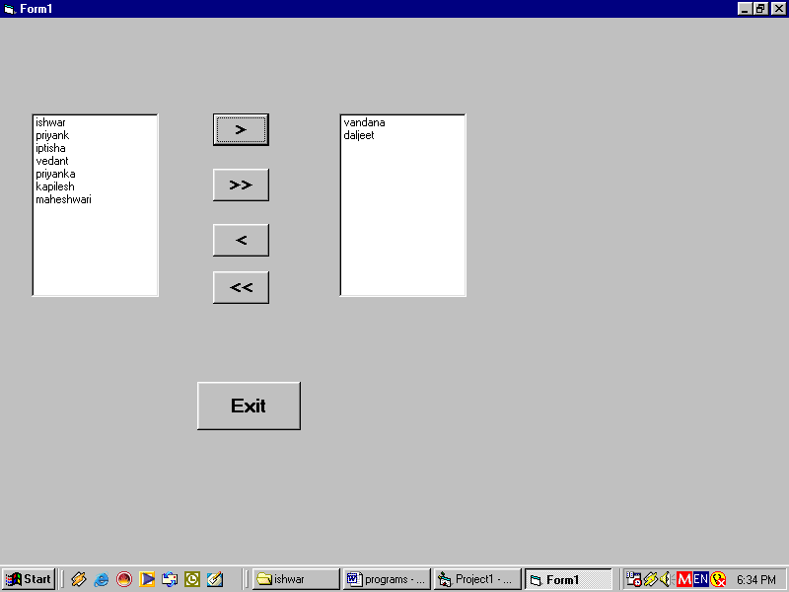

Private Sub Command1_Click()
Dim ind As Integer
Dim str As String
ind = List1.ListIndex
If ind >= 0 Then
str = List1.Text
List2.AddItem str
List1.RemoveItem ind
End If
Command1.Enabled = List1.ListCount > 0
Command2.Enabled = List1.ListCount > 0
Command3.Enabled = List2.ListCount > 0
Command4.Enabled = List2.ListCount > 0
End Sub

Private Sub Command2_Click()
Dim i, n As Integer
Dim str As String
n = List1.ListCount - 1
For i = 0 To n
List1.ListIndex = i
List2.AddItem List1.Text
Next i
List1.Clear
Command1.Enabled = False
Command2.Enabled = False
Command3.Enabled = True
Command4.Enabled = True
End Sub

Private Sub Command3_Click()
Dim ind As Integer
Dim str As String
ind = List2.ListIndex
If ind >= 0 Then
str = List2.Text
List1.AddItem str
List2.RemoveItem ind
End If
Command1.Enabled = List1.ListCount > 0
Command2.Enabled = List1.ListCount > 0
Command3.Enabled = List2.ListCount > 0
Command4.Enabled = List2.ListCount > 0
End Sub

Private Sub Command4_Click()
Dim i, n As Integer
Dim str As String
n = List2.ListCount - 1
For i = 0 To n
List2.ListIndex = i
List1.AddItem List2.Text
Next i
List2.Clear
Command1.Enabled = True
Command2.Enabled = True
Command3.Enabled = False
Command4.Enabled = False
End Sub

Private Sub Command5_Click()
End
End Sub

Private Sub Form_Load()
List1.Text = ""
List2.Text = ""
Command3.Enabled = False
Command4.Enabled = False
List1.AddItem "ishwar"
List1.AddItem "priyank"
List1.AddItem "daljeet"
List1.AddItem "iptisha"
List1.AddItem "kapilesh"
List1.AddItem "vedant"
List1.AddItem "maheshwari"
List1.AddItem "priyanka"
List1.AddItem "vandana"
End Sub

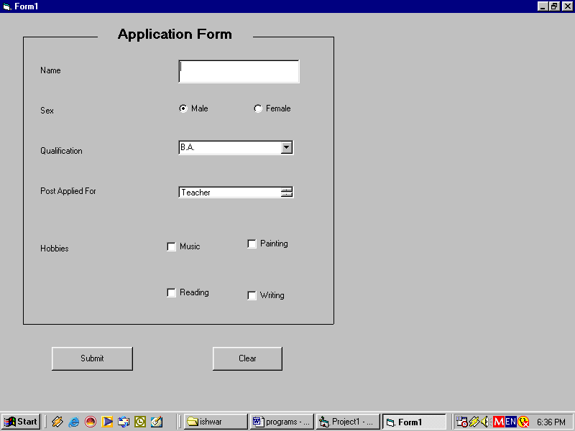

Private Sub Command1_Click()
MsgBox (Text1.Text & " your data for the post of " & List1.Text & " has been submitted")
End Sub

Private Sub Command2_Click()
Text1.Text = ""
Option1.Value = True
Combo1.Text = "B.A."
Check1.Value = False
Check2.Value = False
Check3.Value = False
Check4.Value = False
End Sub

Question : Program to connect a table with the form using adodb.

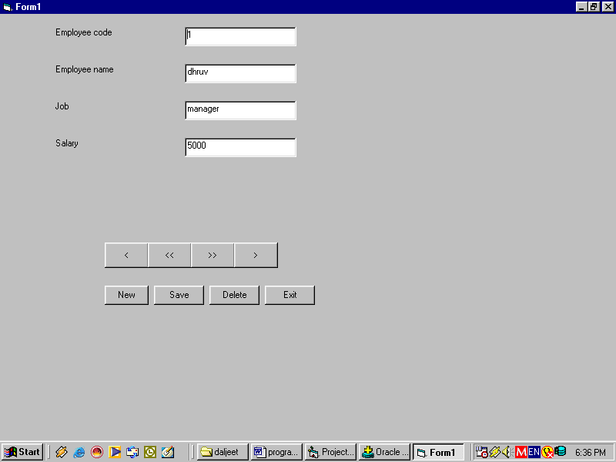

Private Sub Command1_Click()
rst.Close
cn.Close
End
End Sub

Private Sub Command2_Click()
rst.MoveFirst
End Sub

Private Sub Command3_Click()
rst.MovePrevious
If (rst.BOF = True) Then
rst.MoveFirst
End If

End Sub

Private Sub Command4_Click()
rst.MoveNext
If (rst.EOF = True) Then
rst.MoveLast
End If
End Sub

Private Sub Command5_Click()
rst.MoveLast
End Sub

Private Sub Command6_Click()
rst.AddNew
Text1.SetFocus
End Sub

Private Sub Command7_Click()
If (MsgBox("are u sure , u want to save the record ?", vbYesNo) = vbYes) Then
rst.Update
MsgBox "record saved"
End If
End Sub

Private Sub Command9_Click()
rst.Delete
rst.MoveNext

If (rst.EOF = True) Then
rst.MoveLast
End If

End Sub

Private Sub Form_Load()
cn.ConnectionString = "provider=MSDAORA;user id=scott; password=tiger;"
cn.CursorLocation = adUseClient

cn.Open

If cn.State = adStateOpen Then
MsgBox "the connection is now open'"
Else
MsgBox "sorry! the connection could not be open"
End
End If

rst.Open "emp1", cn, adOpenDynamic, adLockOptimistic, adCmdTable

Set Text1.DataSource = rst
Text1.DataField = "ecode"

Set Text2.DataSource = rst
Text2.DataField = "ename"

Set Text3.DataSource = rst
Text3.DataField = "job"

Set Text4.DataSource = rst
Text4.DataField = "salary"

End Sub

